MAKERERE  UNIVERSITY
COLLEGE OF COMPUTING AND INFORMATION SCIENCES DEPARTMENT OF NETWORKS

COURSE: BACHELOR OF SCIENCE IN SOFTWARE ENGINEERING
COURSE UNIT: DATA STRUCTURES AND ALGORITHMS

COURSE CODE: CSC 2100

GROUP: B2
GROUP MEMBERS
NAME | REGISTRATION NUMBER
SSEKIJJOBA FRANCIS | 25/U/04324/PS
NASSUUNA PATIENCE R | 25/U/04295/PS
NUWAGABA DUNCAN | 25/U/0392
OYET ANTHONY ELIZEOUS | 25/E/04316/PS
BIDAL DANIEL | 25/E/04188/PS

What Axioms are in place for array operations
Fixed size: A traditional array has a declared capacity that cannot be changed directly after creation.
Homogeneous elements: Elements in an array have the same declared data type.
Contiguous memory allocation: Array elements occupy consecutive memory locations.
Indexing: Elements are accessed using an index, starting from 0 in C and Java.
Traversal of a single-dimension, 2-dimension, 3-dimension arrays
1. Single-Dimensional Array Traversal
Algorithm: TRAVERSE_ARRAY(A)
Input: An array A[L ... U] with elements.
Output: Elements of A processed according to the function PROCESS().
Steps:
1. Set i ← L
2. While i ≤ U do
1.PROCESS(A[i]) // perform required operation on an element
2. i ← i + 1
3. End While
4. Stop.
2. Two-Dimensional Array Traversal
Algorithm: TRAVERSE_2D_ARRAY(A)
Input: A two-dimensional array A[L1 ... U1, L2 ... U2] with elements.
Output: Elements of A processed according to the function PROCESS().
Steps:
1. Set i ← L1
2. While i ≤ U1 do
1. Set j ← L2
2. While j ≤ U2 do
1. PROCESS(A[i][j]) // perform required operation on an element
2.j ← j + 1
3. End While
4. i ← i + 1
3. End While
4. Stop.
3. Three-Dimensional Array Traversal
Algorithm: TRAVERSE_3D_ARRAY(A)
Input: A three-dimensional array A[L1 ... U1, L2 ... U2, L3 ... U3] with elements.
Output: Elements of A processed according to the function PROCESS().
Steps:
1. Set i ← L1
2. While i ≤ U1 do
1. Set j ← L2
2. While j ≤ U2 do
1. Set k ← L3
2. While k ≤ U3 do
1.PROCESS(A[i][j][k]) // perform required operation on an element
2.k ← k + 1
3. End While
4.j ← j + 1
3. End While
4. i ← i + 1
3. End While
4. Stop.
Base Address of Each Array
Base address for the 1D array is &A[0] because it is the address of the first element
Base address for the 2D array is &A[0][0]
Base address for the 3D array is &A[0][0][0]

MULTIPLY_LINKED_LIST(head, k)
Input: head, k
Output: A new linked list representing the product

1. Create an empty result list.
2. Set carry = 0.
3. Set current = head.
4. WHILE current != NULL
product = current.data * k + carry
digit = product MOD 10
carry = product DIV 10
Create a new node containing digit.
Append the node to the result list.
current = current.next
END WHILE

5. WHILE carry > 0
digit = carry MOD 10
Create a new node containing digit.
Append the node to the result list.
carry = carry DIV 10
END WHILE
6. RETURN result head.

Merging 2 circular linked lists
Algorithm MERGE_CL(HEADER1, HEADER2)

Steps:
1. If (HEADER1.LINK = HEADER1) then
1. HEADER1.LINK = HEADER2.LINK
2. HEADER2.LINK = HEADER2
3. Stop
2. EndIf
3. If (HEADER2.LINK = HEADER2) then
1. Stop
4. EndIf

5. ptr1 = HEADER1.LINK
6. While (ptr1.LINK != HEADER1) do
1. ptr1 = ptr1.LINK
7. EndWhile

8. ptr2 = HEADER2.LINK
9. While (ptr2.LINK != HEADER2) do
1. ptr2 = ptr2.LINK
10. EndWhile

11. ptr1.LINK = HEADER2.LINK
12. ptr2.LINK = HEADER1
13. HEADER2.LINK = HEADER2
14. Stop

Algorithms for Double Linked Lists
Algorithm INSERT_DL_FRONT(X)

Input: X, the data to be inserted.
Output: A double linked list with X at the front.
Data structure: HEADER points to the header node.

Steps:
1. ptr = HEADER.RLINK
2. new = GETNODE(NODE)
3. If (new != NULL) then
1. new.LLINK = HEADER
2. HEADER.RLINK = new
3. new.RLINK = ptr
4. ptr.LLINK = new
5. new.DATA = X
Else
1. Print "Unable to allocate memory"
4. EndIf
5. Stop

Algorithm INSERT_DL_END(X)

Input: X, the data to be inserted.
Output: A double linked list with X at the end.
Data structure: HEADER points to the header node.

Steps:
1. ptr = HEADER
2. While (ptr.RLINK != NULL) do
1. ptr = ptr.RLINK
3. EndWhile
4. new = GETNODE(NODE)
5. If (new != NULL) then
1. new.LLINK = ptr
2. ptr.RLINK = new
3. new.RLINK = NULL
4. new.DATA = X
Else
1. Print "Unable to allocate memory"
6. EndIf
7. Stop

Algorithm INSERT_DL_ANY(X, KEY)

Input: X, the data to insert; KEY, the data of the node
after which X is to be inserted.
Output: A double linked list containing the new node.

Steps:
1. ptr = HEADER
2. While (ptr.DATA != KEY) and (ptr.RLINK != NULL) do
1. ptr = ptr.RLINK
3. EndWhile
4. new = GETNODE(NODE)
5. If (new = NULL) then
1. Print "Memory is not available"
2. Exit
6. EndIf
7. If (ptr.RLINK = NULL) then
1. new.LLINK = ptr
2. ptr.RLINK = new
3. new.RLINK = NULL
4. new.DATA = X
Else
1. ptr1 = ptr.RLINK
2. new.LLINK = ptr
3. new.RLINK = ptr1
4. ptr.RLINK = new
5. ptr1.LLINK = new
6. ptr = new
7. new.DATA = X
8. EndIf
9. Stop

Algorithm DELETE_DL_FRONT()

Input: A double linked list.
Output: A double linked list without its first node.

Steps:
1. ptr = HEADER.RLINK
2. If (ptr = NULL) then
1. Print "List is empty: No deletion is made"
2. Exit
3. EndIf
4. ptr1 = ptr.RLINK
5. HEADER.RLINK = ptr1
6. If (ptr1 != NULL) then
1. ptr1.LLINK = HEADER
7. EndIf
8. RETURNNODE(ptr)
9. Stop

Algorithm DELETE_DL_END()

Input: A double linked list.
Output: A double linked list without its last node.

Steps:
1. ptr = HEADER
2. While (ptr.RLINK != NULL) do
1. ptr = ptr.RLINK
3. EndWhile
4. If (ptr = HEADER) then
1. Print "List is empty: No deletion is made"
2. Exit
Else
1. ptr1 = ptr.LLINK
2. ptr1.RLINK = NULL
3. RETURNNODE(ptr)
5. EndIf
6. Stop

Algorithm DELETE_DL_ANY(KEY)

Input: A double linked list and KEY, the data to delete.
Output: A double linked list without the node containing KEY.

Steps:
1. ptr = HEADER.RLINK
2. If (ptr = NULL) then
1. Print "List is empty: No deletion is made"
2. Exit
3. EndIf
4. While (ptr.DATA != KEY) and (ptr.RLINK != NULL) do
1. ptr = ptr.RLINK
5. EndWhile
6. If (ptr.DATA = KEY) then
1. ptr1 = ptr.LLINK
2. ptr2 = ptr.RLINK
3. ptr1.RLINK = ptr2
4. If (ptr2 != NULL) then
1. ptr2.LLINK = ptr1
EndIf
5. RETURNNODE(ptr)
Else
1. Print "The node does not exist in the given list"
7. EndIf
8. Stop

Implementation: LIFO & FIFO Data Structures based on the projects we did

1. Our Two Applications
Following the brief's implementation matrix, we chose the pairing where the Stack is built in C using an array and the Queue is built in Java using a linked list. Both programs are menu-driven: they keep showing a menu and running the user's choice until the user exits. In both, the data structure code is kept separate from the main program, and no built-in stack or queue library is used.
 | Project A: Stac |  | k (LIFO) | Project B: Queue (FIFO)
Application | Popup Manager |  |  | Call Centre Support Queue
Language | C |  |  | Java
Underlying structure | Array |  |  | Linked list
Folder |  | Project_A_Stack |  |  | Project_B_Queue
Project A: Popup Manager. This models popup windows stacking on top of each other on a PC screen. Each new popup opens in front and covers the ones behind it, and the only way to see the previous popup is to close the front one with its [x] or the [-] button. The most recently opened popup is therefore always the first one closed, which is Last In, First Out.
Project B: Call Centre Support Queue. This models a helpdesk call centre. Callers join the back of a waiting line, and each time an agent is free they answer the caller who has waited longest. The first caller in is the first caller answered, which is First In, First Out. Each call stores the caller's name, the issue type and a timestamp taken when the call is created.

2. Project A: How push and pop Work on the Array (C)
The stack is a PopupStack structure with two parts: an array popups that holds up to 5 popups (MAX_POPUPS), and an integer top that is the index of the front popup. top is -1 when no popups are open.
- Push (open a popup): we first check isFull (top == MAX_POPUPS - 1) and refuse with a warning if so. Otherwise we increase top by 1 first, and then store the new popup at popups[top].
- Pop (click [x]): we first check isEmpty (top == -1) and warn if so. Otherwise we copy out the popup at popups[top] first, and then decrease top by 1. The old slot is not erased: it is now above top, so it counts as free and the next push overwrites it. The program then uses peek to report which popup has been revealed behind it.
- Peek (view front): reads popups[top] without changing top.
- isEmpty, isFull and size: size is top + 1, because array indexes start at 0.
- Show screen: loops from top down to index 0, so the front popup prints first. Only the front popup shows the [x] button, because only it can be closed.
Edge cases: closing or viewing with no popups open prints a warning; opening a 6th popup is refused with a "screen is full" warning before the user types anything; non-numbers and unknown menu choices are rejected; text longer than the title or message limit is shortened without spilling into the next prompt; blank text gets a default; and end of input exits cleanly.
Code organisation: Ui.h and Ui.c hold the structure and every stack operation (initStack, push, pop, peek, isEmpty, isFull, size, display). Main.c only handles the menu and user input.

3. Project B: How enqueue and dequeue Work on the Linked List (Java)
The queue is a chain of CallNode objects. Each node holds one Call and a next reference to the node behind it. CallCenterQueue keeps three fields: front (the head, the next caller to answer), rear (the tail, the newest caller) and size. When the queue is empty, front and rear are both null.
- Enqueue (receiveCall): we create a new CallNode for the call. If the queue is empty, both front and rear point to it. Otherwise we attach it to the current rear.next and then move rear forward to the new node. size goes up by 1. Nodes only ever join at the tail.
- Dequeue (answerCall): if the queue is empty we print a warning and stop. Otherwise we save the call held by the front node and reassign front to front.next, so the old head drops off the list. If front is now null, the queue has just become empty, so rear is also set to null; without this, rear would keep pointing at a removed node. size goes down by 1.
- Front (viewFront): returns the call at front without removing it. isEmpty is true when front == null, and every other operation uses it as its empty check.
- Show waiting calls (printFullQueue): walks the list from the front using a temporary pointer, so the queue's own front is never moved or lost.
Edge cases: answering or viewing with no calls waiting prints "No calls in the queue." instead of causing a null pointer exception; showing an empty queue prints a message; a blank caller name or issue is rejected; and invalid menu input is rejected. No isFull check is needed, because a linked list grows as needed.
Code organisation: Call, CallNode and CallCenterQueue hold the data and all queue logic. Main only handles the menu and user input.

4. Running the Applications
For the queue implementation i.e. The call center, when the application loads the agent receives the options as shown in the figure below and when it’s empty the application gives a friendly message indicating an empty queue rather than breaking down as shown in Figure 1.
The queue displays the current waiting calls and the agent always chooses first the caller who made a call first following that order, consequently, the last caller is served last.
For the stack, as shown in Figure 4, the user is always showed when the stack is full and cannot add any other items thereafter unless they pop out some.
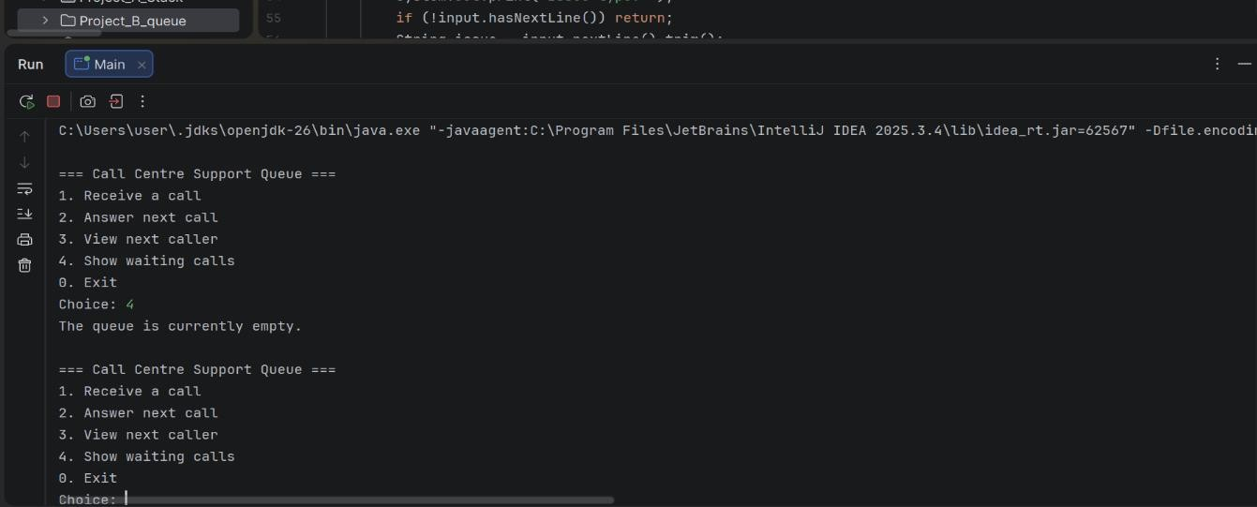
Figure 1 : Initial display when the user first runs the program and no queued calls available
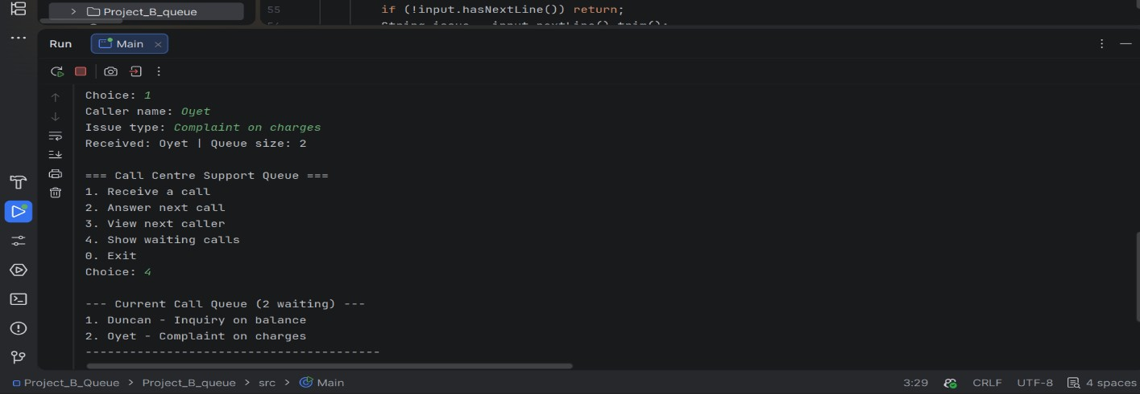
Figure 2 : Demo of Oyet being added last in queue and has to wait for Duncan to be worked on first
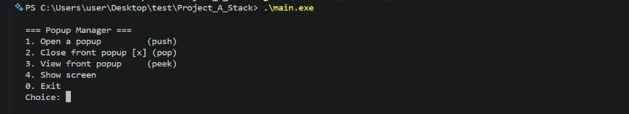
Figure 3: For the stack, demo of first view when loaded
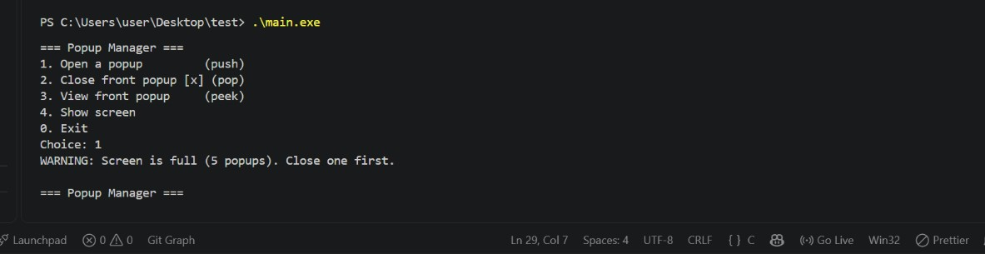
Figure 4: View when the stack is full ,and the user is asked to remove items to proceed

Algorithms and their asymptotic notations
1. Linear Search
A. Appropriate algorithm
Linear Search is used to find a particular element in a list by checking each element sequentially, starting from the first element until the target is found or the list ends.
B. Execution time equation
Let n be the number of elements.
Best case: T(n) =1
Worst case: T(n)= n
Average case: T((n+1)/2) (assuming the target is equally likely to occur at any position).
C. Asymptotic notations
Lower bound =O(1)
Average bound = O(n)
Higher bound =O(n)
D. Nature of data sets
Best case: The target element is at the first position.
Worst case: The target element is at the last position or is not present in the list.
Average case: The target element is somewhere in the middle of the list, requiring approximately half the elements to be checked.

2. Binary Search
Binary Search is used to find a target element in a sorted list. It repeatedly divides the search interval into two halves and eliminates the half that cannot contain the target.
B. Execution time equation
Let n be the number of elements.
Best case: T(n)=1
Worst case: T(n)=T(n/2)+1
Average case: T(n) = O(log2n)
C. Asymptotic notations
Lower bound =O(1)
Average bound = O(log n)
Higher bound =O(log n)
D. Nature of data sets
Best case: The target element is at the middle position of the sorted list.
Worst case: The target is absent or requires searching until the final possible interval.
Average case: The target is located at a position that requires several divisions of the search interval before being found.
Design Strategies we implemented
1. Greedy Algorithm Design Technique
Task Scheduling on Multiple Processors (Load Balancing)
The algorithm assigns each task to the processor with the least workload. It updates the processor's workload after every assignment until all tasks are completed. This helps distribute tasks evenly and reduce processing time.
Unit Fraction Decomposition
The algorithm breaks a fraction into a sum of unit fractions (fractions with numerator 1). It repeatedly selects the largest possible unit fraction that does not exceed the remaining fraction until the fraction is completely decomposed.
Traffic Signal (Intersection Timing Control)
Greedy is used to allocate green-light time based on traffic demand. The direction with the highest number of waiting vehicles is prioritized to reduce congestion and waiting time.

2. Divide and Conquer Algorithm Design Technique
Large-Integer Multiplication
The algorithm divides large numbers into smaller parts, multiplies the parts separately and combines the intermediate results to obtain the final product. This makes multiplication of large numbers more efficient.
Fast Exponentiation (Power by Squaring)
The algorithm calculates powers by repeatedly dividing the exponent by two and squaring the result. This reduces the number of multiplication operations and makes calculating large powers faster.
Election Vote Tallying by Region
The election area is divided into smaller regions where votes are counted independently. The regional results are then combined to obtain the overall election results. This makes vote counting easier and faster.

